DATA ANALYSIS ON GOOGLE PLAYSTORE

In this , I’ve analyzed Google Play Store data. Users downloads the applications for different uses or to perform different tasks that may be paid or free applications.

At first i have seen the shape which is (10358,13) and the null values of the dataset, and also seen whether is there any duplicate values are there or not. By this i have seen there are duplicate values and removed it and filled the NaN values.

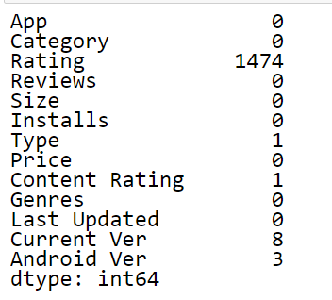

Then by using dtype and make the changes in some of them. For example, in installs there are 10,000+ installs in this i have removed the + and then it will be like 10,000.

And changed the type of the data in the dataset to float

dtype(‘float64’)

the dataset is describe and seen the values i.e., count,mean,std,min,max...

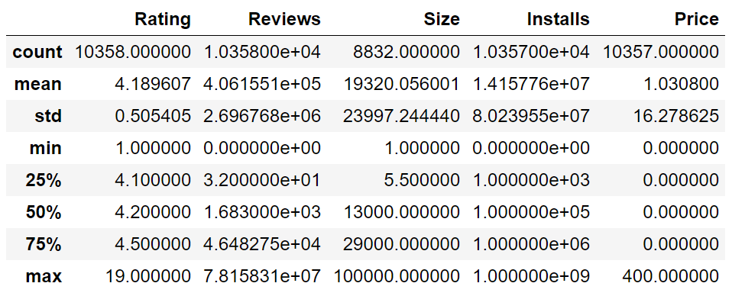

There are unique values for every element in the dataset.

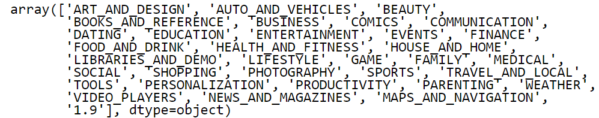

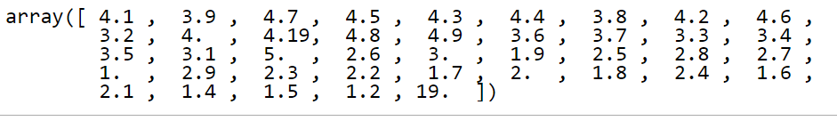

And some other....

With the help of plot it is known that the numerical count of the apps according to their category and seen that the category with family has the most number of apps in the dataset followed by game ,tools..

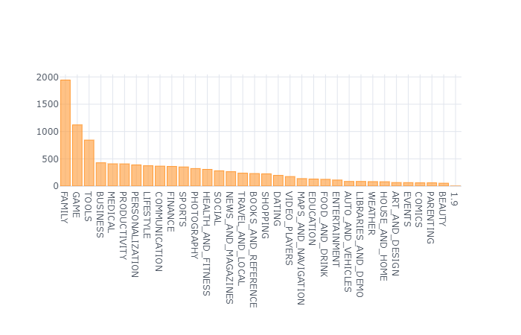

And now here comes the data analysis of this dataset. In this dataset some of the apps are paid and some of them are free. By doing the analysis by using plots i have seen that the apps that provided free is downloaded alot with 92.2% which is greater than paid apps with 7.8%.

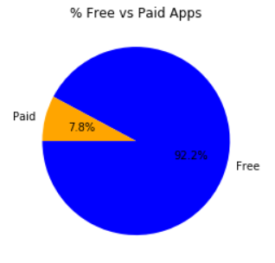

And by seeing the category in which the most number of the apps are free.

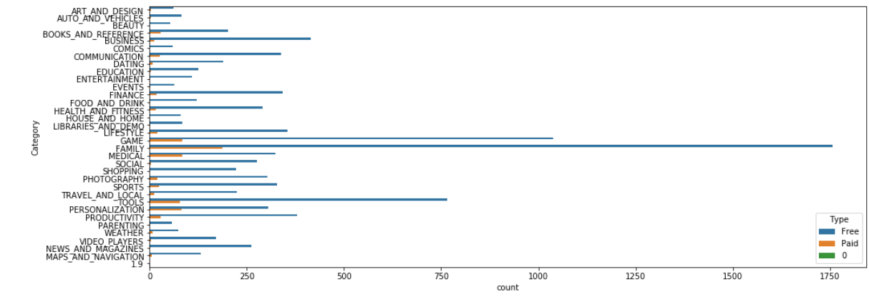

In this most of the apps supports to the mobile phones with android version 4.0 and above but somehow some apps supports with 5.0 and above ,6.0 and above and so on according to their updates.

Higher the rating of the apps the size of the apps is also high that provides services to their customers. The minimum price for paid is starts from $2 and continues above and costliest app is of $400.

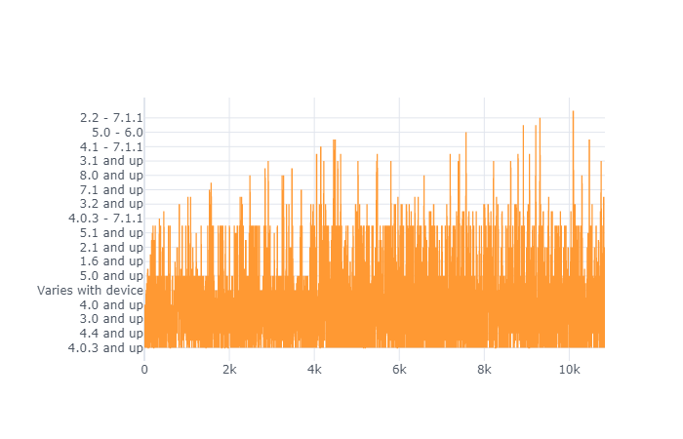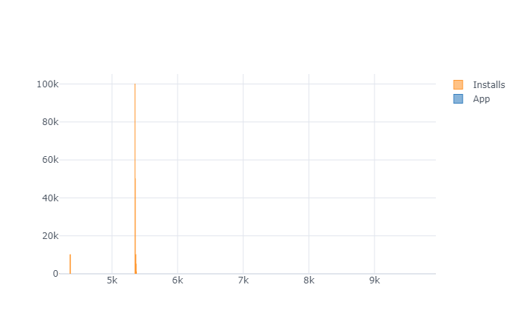

What about their rating?... most of the free apps have rating of 4 stars as like paid apps the paid apps have 4 star rating as they have charges of use. Apps related to EDUCATION, LIFESTYLE and TOOLS seems to be got food ratings. In a few categories such as COMMUNICATION, FINANCE and PHOTOGRAPHY, the average ratings of free apps are higher than those of paid apps. We can also see the curve goes high in between 4.0 to 4.7.

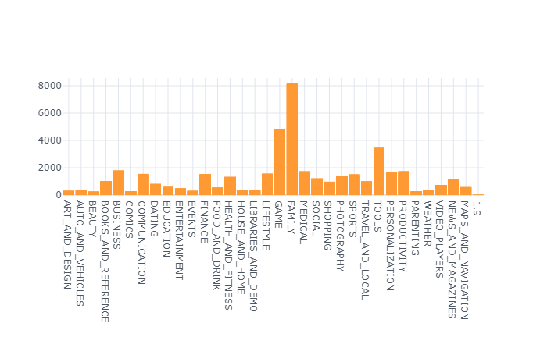

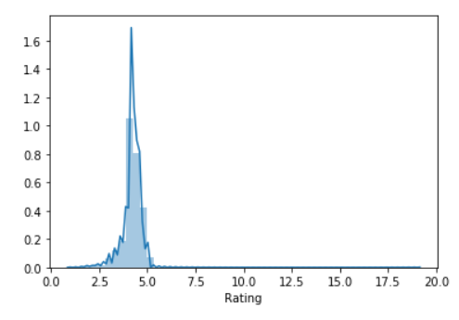

As we already seen the family category apps are more in number a plot is drawn to see the rating among them and rating of 4.19 is there for most number of apps in family .

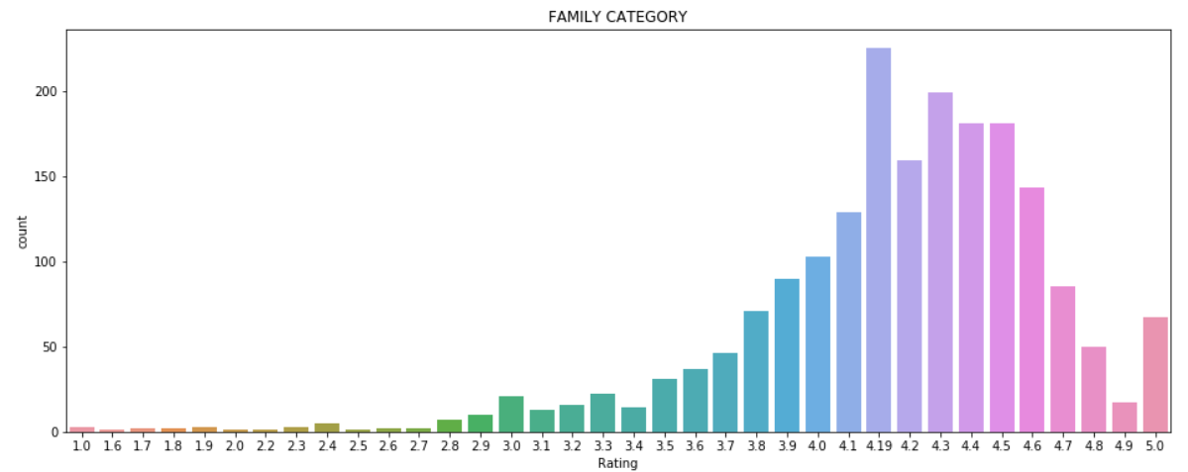

While in the next most number of apps of category game has the rating of 4.5 to more of of its apps.

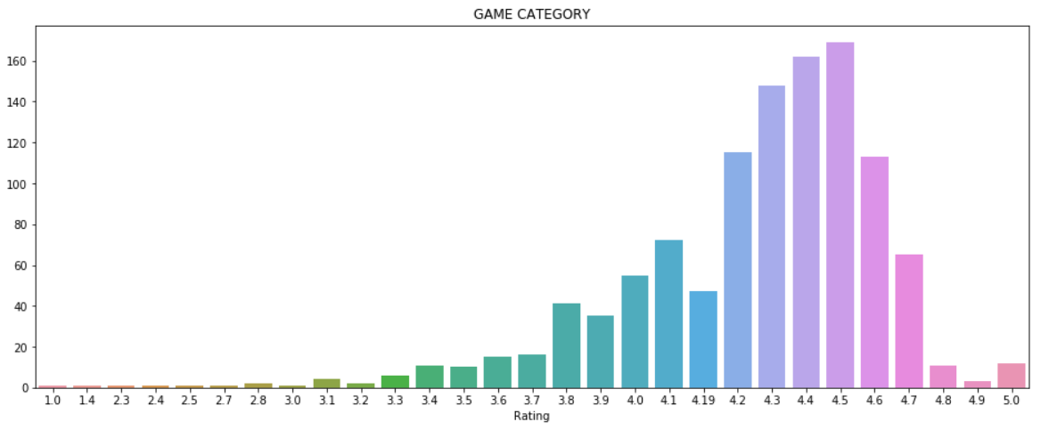

In case of 4+star rating apps like facebook, telegram, whatsapp, amazon and so on are free apps and provide good services while seeing their positive reviews and also provide content to everyone that may be teen, 18+, old e.t.c,

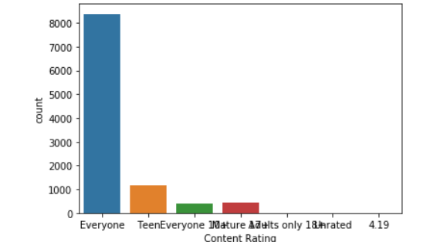

While paid apps like some gaming apps, entertainment apps and so on also provide services to everyone and some other are content rating. While doing the plot for rating for overall apps that is seen that the rating is between 0 to 5 star but the curve is high in between 4 to 4.7 stars and they also have big number of size, there are the apps which have got 5 star rating by the audience.

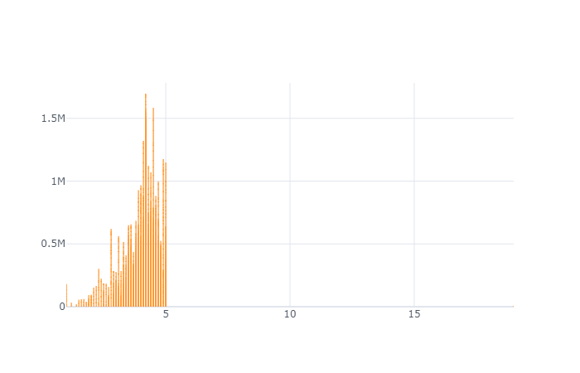

While the apps gets more reviews gets the good rating. Apps in between the rating 4 to 4.5 gets more reviews than the apps which got the rating of 5

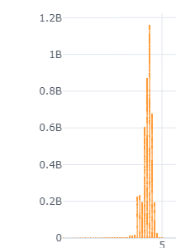

As the apps are paid and also free. The Content rating matters here and audience choose app according to their task to be preformed. The teen choose free apps mostly.

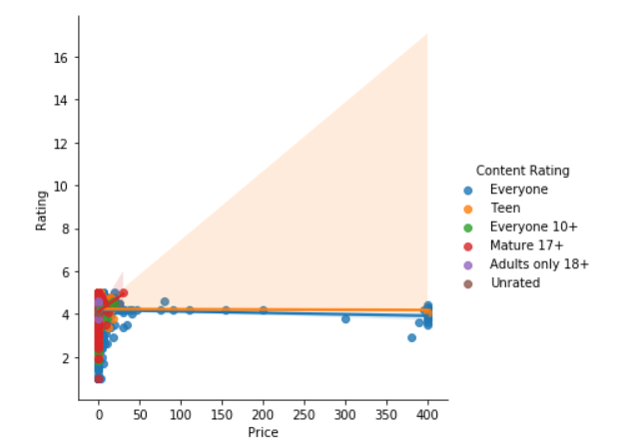

Here is the amount of apps that are rated high and low. 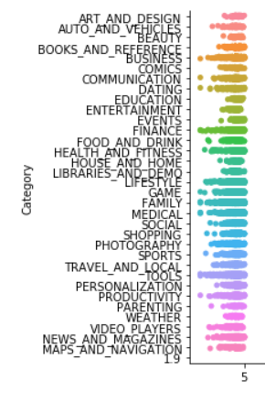

The app size is more that may be any category is high when the rating is 4 and above when the app has reviews of greater than 10L

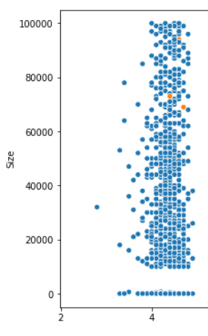

By seeing the reviews and the rating greater than 4.5, the apps of the category are classified as most popular.

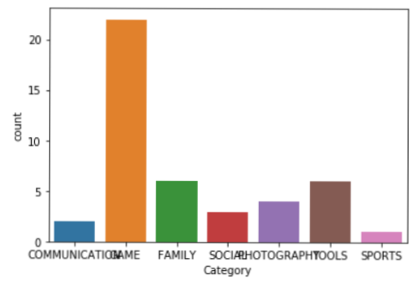

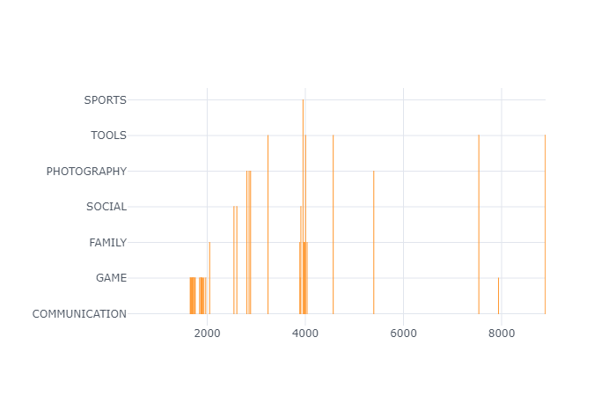

Now the reviews with greater than 60000000 is whatsapp, facebook, instagram.

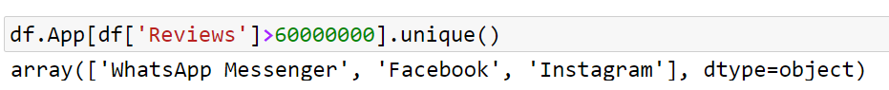

The apps that are downloaded more than 100 million are 44

